**S-128**



Published by the

International Hydrographic Organization

4b quai Antoine 1er

Principauté de Monaco

Tel: (377) 93.10.81.00

Fax: (377) 93.10.81.40

info@iho.int

www.iho.int

Published by the

International Hydrographic Organization

4b quai Antoine 1er

Principauté de Monaco

Tel: (377) 93.10.81.00

Fax: (377) 93.10.81.40

info@iho.int

www.iho.int

**Catalogue of Nautical Products**

**Edition 2.0.0 – March 2025**

|  |
| --- |
| © Copyright International Hydrographic Organization 2025 |
| This work is copyright. Apart from any use permitted in accordance with the [Berne Convention for the Protection of Literary and Artistic Works](http://www.wipo.int/treaties/en/ip/berne/trtdocs_wo001.html) (1886), and except in the circumstances described below, no part may be translated, reproduced by any process, adapted, communicated or commercially exploited without prior written permission from the International Hydrographic Organization (IHO). Copyright in some of the material in this publication may be owned by another party and permission for the translation and/or reproduction of that material must be obtained from the owner. |
| This document or partial material from this document may be translated, reproduced or distributed for general information, on no more than a cost recovery basis. Copies may not be sold or distributed for profit or gain without prior written agreement of the IHO Secretariat and any other copyright holders. |
| In the event that this document or partial material from this document is reproduced, translated or distributed under the terms described above, the following statements are to be included: |
| *“Material from IHO publication [reference to extract: Title, Edition] is reproduced with the permission of the IHO Secretariat (Permission No ……./…) acting for the International Hydrographic Organization (IHO), which does not accept responsibility for the correctness of the material as reproduced: in case of doubt, the IHO’s authentic text shall prevail. The incorporation of material sourced from IHO shall not be construed as constituting an endorsement by IHO of this product.”* |
| *“This [document/publication] is a translation of IHO [document/publication] [name]. The IHO has not checked this translation and therefore takes no responsibility for its accuracy. In case of doubt the source version of [name] in [language] should be consulted.”*  The IHO Logo or other identifiers shall not be used in any derived product without prior written permission from the IHO Secretariat. |

Contents

1 Overview 1

1.1 Introduction 1

1.2 References 1

1.3 Terms, definitions and abbreviations 1

1.3.1 Use of Language 1

1.3.2 Terms and definitions 2

1.3.3 Abbreviations 3

1.4 General S-128 data product description 4

1.5 Data product specification metadata 4

1.6 IHO Product Specification maintenance 5

1.6.1 Introduction 5

1.6.2 New Edition 5

1.6.3 Revision 5

1.6.4 Clarification 5

1.6.5 Version numbers 5

2 Specification Scopes 5

3 Dataset Identification 6

4 Data Content and Structure 6

4.1 Introduction 6

4.2 Application Schema 7

4.3 Feature Catalogue 12

4.3.1 Introduction 12

4.3.2 Feature types 12

4.3.3 Feature relationship 12

4.3.4 Information types 12

4.3.5 Attributes 12

4.4 Geometric representation 13

5 Coordinate Reference Systems (CRS) 14

5.1 Introduction 14

5.2 Horizontal reference system 14

5.3 Projection 14

5.4 Vertical coordinate reference system 14

5.5 Temporal reference system 14

5.6 Coverage of nautical products data and scale 15

6 Data Quality 15

6.1 Introduction 15

7 Data Capture and Classification 15

8 Maintenance 16

8.1 Introduction 16

8.2 Production process for base and update datasets 16

8.3 Dataset updates and cancellation 16

8.4 Support file updates 16

8.5 Feature and Portrayal Catalogues 16

8.6 Feature history, version, and change tracking 16

8.7 Dataset encryption 17

9 Portrayal 17

9.1 Portrayal Catalogue 17

10 Data Product Format (Encoding) 17

10.1 Introduction 17

10.2 Coordinate encoding in spatial primitives 18

10.2.1 Encoding of coordinates as decimals 18

10.3 Numeric attribute encoding 18

10.4 Text attribute values 18

10.5 Mandatory attribute values 18

10.6 Data overlap 18

10.7 Data extent 19

11 Data Product Delivery 19

11.1 Data product delivery information 19

11.1.1 Dataset loading 19

11.1.2 New Editions 19

11.1.3 Update 19

11.2 Dataset 19

11.2.1 Datasets 19

11.2.2 Dataset file naming 20

11.2.3 Update dataset file naming 21

11.3 Support files 21

11.3.1 Support file naming 21

11.4 Exchange Set 22

12 Metadata 22

12.1 Introduction 22

12.2 Discovery metadata 22

12.2.1 S100_ExchangeCatalogue 25

12.2.2 S100_DatasetDiscoveryMetadata 26

12.2.3 S100_SupportFileDiscoveryMetadata 33

12.2.4 S100_CatalogueDiscoveryMetadata 36

12.2.5 Miscellaneous metadata types 37

**Document History**

Changes to this Product Specification are coordinated by the IHO Nautical Information Provision Working Group (NIPWG). New editions will be made available via the IHO web site. Maintenance of the Product Specification shall conform to IHO Technical Resolution 2/2007 (as amended).

|  |  |  |  |
| --- | --- | --- | --- |
| **Version Number** | **Date** | **Approved By** | **Purpose** |
| 0.0.1 | 28 Dec 2018 | KHOA | First Draft |
| 0.7.5 | 20 Nov 2019 | KHOA | Working Draft |
| 1.0.0 | 11 Mar 2022 | KHOA | Release 1.0.0 |
| 1.0.0 | May 2022 | HSSC | Initial published version for evaluation and testing. |
| 1.1.0 | Oct 2023 | KHOA | Updated to align with S-100 Edition 5.0.0 |
| 1.2.0 | Feb 2024 | KHOA | Revised Data Modeling |
| 2.0.0 | Mar 2024 | KHOA | Updated to align with S-100 Edition 5.2.0 and Applied feedback from NIPWG |
| 2.0.0 | July 2024 | KHOA | Applied feedback from NIPWG |
| 2.0.0 | Mar 2025 | IHO CL xx/2025 | First operational version of S-128 |
|  |  |  |  |
|  |  |  |  |
|  |  |  |  |
|  |  |  |  |
|  |  |  |  |

Page intentionally left blank

# Overview

## Introduction

This document has been produced by the IHO Nautical Information Provision Working Group (NIPWG) in response to a requirement to produce a data product that can be used as a Nautical Publication Information Overlay (NPIO) within an Electronic Chart Display and Information System (ECDIS). It is based on the IHO S-100 framework Specification and the ISO 19100 series of standards. It is a vector Product Specification that is primarily intended for encoding the content of Catalogues of Nautical Products, for navigational purposes.

Catalogue of Nautical Products (CNP) datasets describe the availability of paper charts, ENCs and other nautical products, applications for navigational purposes, online services and e-Navigation services. This includes their issue date, status, producing agency, and coverage.

## References

S-100: *IHO Universal Hydrographic Data Model*, Edition 5.2.0

ISO 8601:2004: *Data elements and interchange formats - Information interchange - Representation of dates and times.*

ISO 19101-1:2014: G*eographic Information - Reference Model - Part 1- Fundamentals*

ISO 19101-2:2018: G*eographic Information - Reference model*.

ISO/TS 19103:2005: G*eographic Information - Conceptual schema language*.

ISO 19106:2004: *Geographic Information – Profiles*.

ISO 19107:2019: *Geographic Information – Spatial schema*.

ISO 19108:2002: *Geographic Information – Temporal Schema.*

ISO 19109:2005: *Geographic Information - Rules for Application Schema*.

ISO 19110:2005: *Geographic Information - Methodology for Feature Cataloguing*

ISO 19111:2007: *Geographic information - Spatial referencing by coordinates*.

ISO 19115-1:2018: *Geographic information – Metadata*, Amended by Amendment 1.

ISO 19115-2:2019: *Geographic information - Metadata: Extensions for imagery and gridded data*.

ISO 19117:2012: *Geographic information - Portrayal*

ISO 19123:2005: *Geographic information - Schema for coverage geometry and functions*.

ISO 19129:2009: *Geographic information - Imagery gridded and coverage data framework*.

ISO 19131:2008: *Geographic information - Data product specifications*.

ISO 19136:2020: *Geographic Information – Geography Markup Language*.

ISO 19136-2:2015: *Geographic Information – Geography Markup Language*.

ISO/TS 19139:2007 *Geographic Information – Metadata – XML schema implementation*.

ISO 19157:2013: *Geographic Information – Data Quality*

## Terms, definitions and abbreviations

### Use of Language

Within this document:

* “Must” indicates a mandatory requirement.
* “Should” indicates an optional requirement, that is the recommended process to be followed, but is not mandatory.
* “May” means “allowed to” or “could possibly”, and is not mandatory.

### Terms and definitions

The S-100 framework is based on the ISO 19100 series of geographic standards. The terms and definitions provided here are used to standardize the nomenclature found within that framework, whenever possible. They are taken from the references cited in clause 1.2. Modifications have been made when necessary.

**Application**

Manipulation and processing of data in support of user requirements (ISO 19101).

**Application Schema**

Conceptual schema for data required by one or more applications (ISO 19101).

**Conceptual Model**

Model that defines concepts of a universe of discourse (ISO 19101).

**Conceptual Schema**

Formal description of a conceptual model (ISO 19101).

**Coverage**

**Feature** that acts as a function to return values from its range for any direct position within its spatial, temporal or spatiotemporal **domain** (ISO 19123).

EXAMPLE: Raster image, polygon overlay, digital elevation matrix.

**Data Product**

**Dataset** or **dataset series** that conforms to a **data Product Specification**.

**Data Product Specification**

Detailed description of a **dataset** or **dataset series** together with additional information that will enable it to be created, supplied to, and used by another party.

NOTE: A data Product Specification provides a description of the universe of discourse and a specification for mapping the universe of discourse to a dataset. It may be used for production, sales, end-use, or other purpose.

**Dataset**

Identifiable collection of data (ISO 19115).

NOTE: A dataset may be a smaller grouping of data which, though limited by some constraint such as spatial extent or feature type, is located physically within a larger dataset. Theoretically, a dataset may be as small as a single feature or feature attribute contained within a larger dataset. A hardcopy map or chart may be considered a dataset.

**Dataset Series**

Collection of **datasets** sharing common characteristics (ISO c19115).

**Domain**

Well-defined set (ISO/TS 19103).

NOTE: Well-defined means that the definition is both necessary and sufficient, as everything that satisfies the definition is in the set and everything that does not satisfy the definition is necessarily outside the set.

**Feature**

Abstraction of real world phenomena (ISO 19101).

NOTE: A feature can occur as a type or an instance. Feature type or feature instance will be used when only one is meant.

**Feature Association**

Relationship that links instances of one **feature** type with instances of the same or a different **feature** type (ISO19110).

**Feature Attribute**

Characteristic of a **feature** (ISO 19101-1:2014, 4.1.12).

EXAMPLE 1: A feature attribute named “colour” can have an attribute value “green” which belongs to the data type “text”.

EXAMPLE 2: A feature attribute named length can have an attribute value “82.4” which belongs to the data type “real”.

NOTE 1: A feature attribute has a type name, a data type and a value domain associated to it. A feature attribute for a feature instance also has an attribute value taken from the value domain.

NOTE 2: In a Feature Catalogue a feature attribute can include a value domain but does not specify attribute values for feature instance.

NOTE 3: In UML, attribute associations and operations are representation types and are not fundamental to the type of a characteristic nor to the type of feature. All three are equally capable of representing the same characteristics of a feature. Every implementation of a characteristic is allowed to use the representation type that is most appropriate and can use several different representations for a single characteristic if required.

Feature associations and feature operations therefore are different types of feature attribute, the distinction between them being based on storage and access mechanism rather than semantics.

**Geographic Data**

Data with implicit or explicit reference to a location relative to the Earth (ISO 19109).

NOTE: Geographic information is also used as a term for information concerning phenomena implicitly or explicitly associated with a location relative to the Earth.

**Metadata**

Information about a resource (ISO 19115 – 1: 2014, 4.10).

**Model**

Abstraction of some aspects of reality (ISO 19109).

**Portrayal**

Presentation of information to humans (ISO 19117).

NOTE: Within the scope of this International Standard Portrayal is restricted to the portrayal of geographic information” (ISO 19117:2012; 4.20).

**Quality**

Totality of characteristics of a product that bear on its ability to satisfy stated and implied needs (ISO 19101).

**Universe of Discourse**

View of the real or hypothetical world that includes everything of interest (ISO 19101).

### Abbreviations

This Product Specification adopts the following convention for symbols and abbreviated terms:

ASCII American Standard Code for Information Interchange

CNP Catalogue of Nautical Products

DCEG Data Classification and Encoding Guide

ECDIS Electronic Chart Display and Information Systems

ENC Electronic Navigational Chart

GML Geography Markup Language

IHO International Hydrographic Organization

IOC International Oceanographic Commission

ISO International Organization for Standardization

NIPWG IHO Nautical Information Provision Working Group

NPIO Nautical Publication Information Overlay

UML Unified Modeling Language

URI Uniform Resource Identifier

URL Uniform Resource Locator

WMS Web Map Service

WFS Web Feature Service

www World Wide Web

WGS World Geodetic System

XML eXtensible Markup Language

XSLT eXtensible Stylesheet Language Transformations

## General S-128 data product description

NOTE: This clause contains general information about the data product

Title: Catalogue of Nautical Products Product Specification

Abstract: Catalogue of Nautical Products (CNP) datasets describe the availability and reliability of paper chart, ENC, S-100 based nautical products, application for navigational purpose, online service and e-Navigation services. This includes their issue date, publication status, producing agency, and source indication. CNP is intended to exchange status of nautical products and to be a supplement to ENC, and therefore does not describe the geographic information in detail equal to ENC, rather it is shown as a coverage of nautical products.

Content: Datasets conforming to this Specification will contain Catalogues of some of relevant nautical products information for the area of coverage such as paper chart, ENC, Nautical Publication, S-100 based nautical products and e- Navigation service.

Spatial Extent:

Description: Global coverage of maritime areas.

East Bounding Longitude: 180°

West Bounding Longitude: -180°

North Bounding Latitude: 90°

South Bounding Latitude: -90°

Purpose: Describing status of nautical products, and to allow the producer to exchange catalogue of nautical products with interested stakeholders.

## Data product specification metadata

NOTE: This information uniquely identifies this Product Specification and provides information about its creation and maintenance. For further information on dataset metadata see clause 12.

Title: Catalogue of Nautical Products

S-100 Version:5.2.0

S-128 Version: 2.0.0

Date: March 2025

Language: English

Classification: Unclassified

Contact: International Hydrographic Organization (IHO)

4b quai Antoine 1er,

B.P 445

MC 98011 MONACO CEDEX

Telephone : +377 93 10 81 00

Fax : + 377 93 10 81 40

Email : [info@iho.int](mailto:info@iho.int)

URL: <https://iho.int>

Identifier: S-128

Maintenance: Amendments to this Specification will be produced on a needs basis. For reporting issues with this Specification which need correction, use the contact information.

## IHO Product Specification maintenance

### Introduction

Changes to S-128 will be released by the IHO as a new edition, revision, or clarification.

### New Edition

New Editionsof S-128 introduce significant changes. *New Editions* enable new concepts, such as the ability to support new functions or applications, or the introduction of new constructs or data types. *New Editions* are likely to have a significant impact on either existing users or future users of S-10n.

### Revision

*Revisions* are defined as substantive semantic changes to S-128. Typically, revisions will change S-128 to correct factual errors; introduce necessary changes that have become evident as a result of practical experience or changing circumstances. A *revision* must not be classified as a clarification. *Revisions* could have an impact on either existing users or future users of S-128. All cumulative *clarifications* must be included with the release of approved corrections revisions.

Changes in a revision are minor and ensure backward compatibility with the previous versions within the same Edition. Newer revisions, for example, introduce new features and attributes. Within the same Edition, a dataset of one version could always be processed with a later version of the feature and portrayal catalogues.

In most cases a new feature or portrayal catalogue will result in a revision of S-128.

### Clarification

Clarifications are non-substantive changes to S-128. Typically, clarifications: remove ambiguity; correct grammatical and spelling errors; amend or update cross references; insert improved graphics in spelling, punctuation and grammar. A clarification must not cause any substantive semantic change to S-128.

Changes in a clarification are minor and ensure backward compatibility with the previous versions within the same Edition. Within the same Edition, a dataset of one clarification version could always be processed with a later version of the feature and portrayal catalogues, and a Portrayal Catalogue can always rely on earlier versions of the Feature Catalogues.

### Version numbers

The associated version control numbering to identify changes (n) to S-128 must be as follows:

New Editions denoted as **n**.0.0

Revisions denoted as n.**n**.0

Clarifications denoted as n.n.**n**

# Specification Scopes

This Product Specification describes one data product and therefore requires only one scope which is described below:

Scope ID: Catalogue of Nautical Products

Level: 005-dataset

Level name: CNP Dataset

# Dataset Identification

This section describes how to identify data sets that conform to the Specification. A dataset that conforms to this Product Specification may be identified by its discovery metadata as defined in clause 12 of this Specification. The information identifying the data product may include the following items from S-100 Edition 5.2.0, clause 11-6 (adapted from ISO 19131).

Title: Catalogue of Nautical Products

Alternate Title: CNP

Abstract: Catalogue of Nautical Product (CNP) is a vector dataset containing all relevant information regarding Catalogue of Nautical Products like nautical charts and nautical publications.

Geographic Description: EX_GeographicDescription: For example, official name of region

Spatial Resolution: MD_Resolution>equivalentScale.denominator (integer) or MD_Resolution>levelOfDetail (CharacterString). For example, “All scales”

Purpose: Describing status of nautical products, and to allow the producer to exchange Catalogue of Nautical Products with interested stakeholders

Language: English

Classification: Data can be classified as one of the following:

1. Unclassified
2. Restricted
3. Confidential
4. Secret
5. Top Secret
6. Sensitive But Unclassified
7. For Official Use Only
8. Protected
9. Limited Distribution

Spatial Representation Type: MD_SpatialRepresentationTypeCode: vector

Point of Contact: Producing Agency

# Data Content and Structure

## Introduction

The S-128 product is based on the S-100 General Feature Model (GFM), and is a feature-based vector product. Figure 4-1 below shows how the S-128 Application Schema is realized from the S-100 GFM. All S-128 features and information classes are derived from the abstract classes like CatalogueElement and NavigationalProduct defined in the S-128 Application Schema, which realize the GFM meta-classes **S100_GF_FeatureType** and **S100_GF_InformationType** respectively.

This section contains the Application Schema expressed in UML and an associated Feature Catalogue. The Feature Catalogue is included in Annex B, and provides a full description of each feature type including its attributes, attribute values, and relationships in the data product.

The class comprising the S-128 Application Schema is the S-128 Domain model containing the features and information types that model the CNP application domain specifically. Geographic features in all three packages use the spatial types from S-100 Part 7, which are imported as-is into the S-128 spatial type package and therefore can be used as types for S-128 spatial attributes. The spatial types package also contains definitions of ‘union types’ (combinations of the S-100 spatial types), since S-100 allows features to have different kinds of geometry but UML does not allow an attribute of a class to have multiple types. The S-128 Application Schema models spatial attributes as attributes of feature classes.

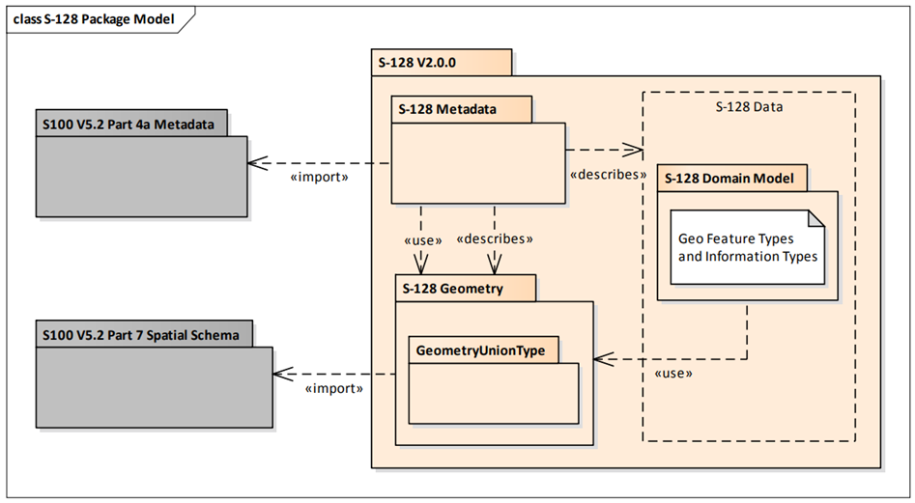

Figure 4-1 – S-128 data model overview

## Application Schema

The UML models shown in the Figures below are the overall CNP Application Schema.

This section contains a general overview of the classes and relationships in the S-128 Application Schema. Detailed information about how to use the feature types and information types to encode CNP information is provided in the S-128 Data Classification and Encoding Guide (DCEG).

The following conventions are used in the UML diagrams depicting the Application Schema:

* Standard UML conventions for classes, associations, inheritance, roles, and multiplicities apply. These conventions are described in Part 1 of S-100.
* *Italic* font for a class name indicates an abstract class.
* Feature classes are depicted with green background; the dark shade for abstract feature classes and the light shade for ordinary (non-abstract) feature classes.
* Information type classes are depicted with blue background; the dark shade for abstract information type classes and the light shade for ordinary information types.
* Association classes are depicted with a white background.
* Complex attributes are depicted with a pink background.
* Enumeration lists and codelists are depicted with a tan background. The numeric code corresponding to each listed value is shown to its right following an ‘=’ sign.
* No significance attaches to the colour of associations.
* Where the association role or name is not explicitly shown, the default rules for roles and names apply:
  + The role name is ‘the<CLASSNAME>’ where <CLASSNAME> is the name of the class to which that association end is linked.
  + The association name is ‘<CLASSNAME1>_<CLASSNAME2>’ where <CLASSNAME1> is the source and <CLASSNAME2> the target. In case of a feature/information association the feature is the source. For feature/feature or information/information associations without explicit names the source/target are indicated by an arrowhead.

The class for geographic features is feature type and the class for information types is information type.

The geographic features included in the S-128 are:

* Electronic Product: Electronic navigation products like S-57 ENC, S-101 ENC, digital charts for special purposes and digital publications based upon such physical publications.
* Physical Product: Navigation products published in paper format.
* S-100 Service: A service that makes use of S-100 based product specifications to support data transfer.

CatalogueElement and NavigationalProduct is an abstract classes from which the geographic feature classes in the Application Schema are derived. CatalogueElement has common attributes which are inherited by all S-128 geographic feature types *NavigationalProduct has common attributes product type products.* To make sense a derived class may impose additional constraints, which will be described in the definition of the derived class or the S-128 DCEG.

Geographic features use spatial types defined in the geometry package for spatial attributes. Datasets comprised of S-128 features are described by metadata as defined in the S-128 metadata package. Metadata uses selected spatial types (specifically, it uses the polygon type to describe the coverage of a dataset).

ContactDetails is the information type in the S-128 domain model. ContactDetails has attributes for contactInstructions, contactAddress, information, onlineResource, and telecommunications and sourceIndication. Information types may be associated to other information types or referenced by associations from feature types. A derived class may impose additional constraints, which will be described in the definition of the derived class or in the S-128 DCEG.

Figures 4-4 show all S-128 enumerations and codelists. The EPSG codelist are not directly implemented in the data model, and full code list can be found at epsg.org. Local datums that can't be found in the code list is encoded using the wildcard and maybe add an example.

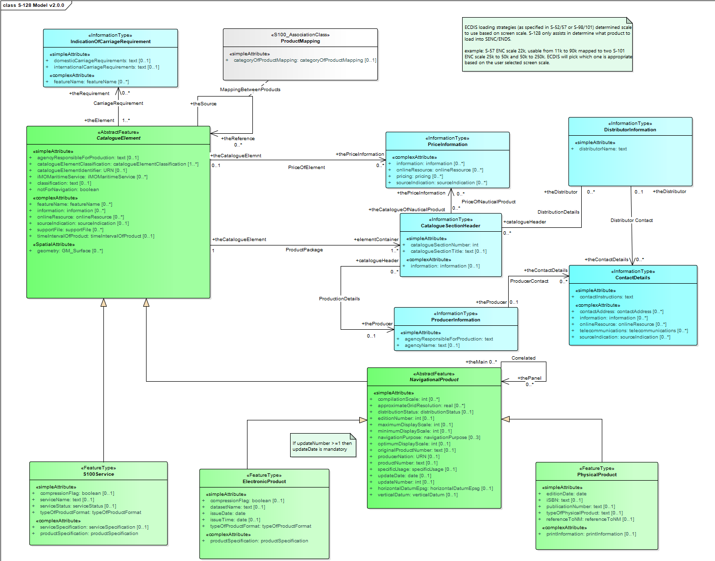**Figure 4-2 – S-128 Application Schema (feature type, information type)**

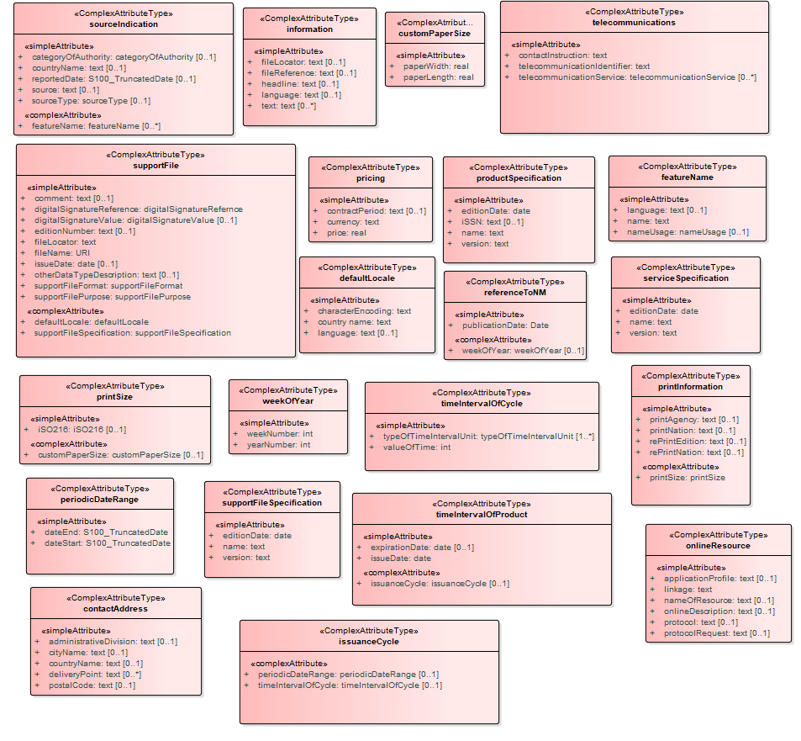**Figure 4-3 – S-128 Application Schema (complex attribute type)**

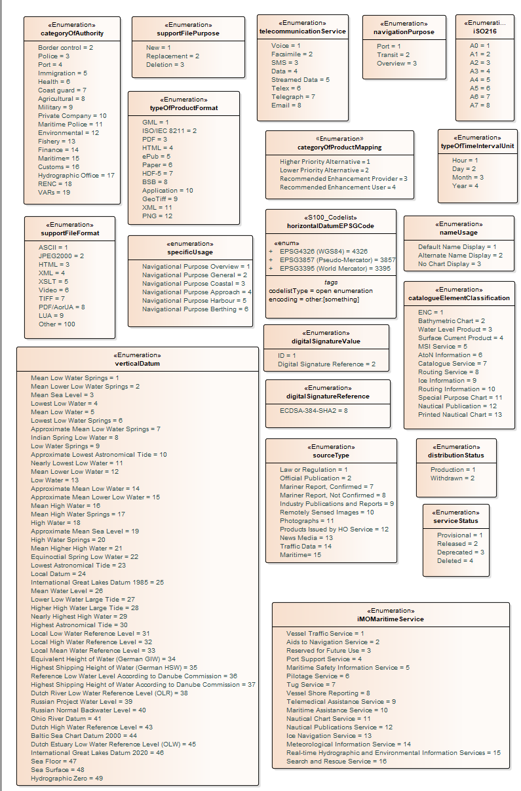

**Figure 4-4 – S-128 Application Schema (enumeration type)**

## Feature Catalogue

### Introduction

The Feature Catalogue describes the feature types, information types, attributes, attribute values, associations and roles which may be used in the product. The S-128 Feature Catalogue is available in an XML document which conforms to the S-100 XML Feature Catalogue Schema and can be downloaded from the IHO Geospatial Information Registry (<https://registry.iho.int>).

### Feature types

Feature types contain descriptive attributes that characterize real-world entities. The word ‘feature’ may be used in one of two senses – feature type and feature instance. A feature type is a class and is defined in a Feature Catalogue. A feature instance is a single occurrence of the feature type and represented as an object in a dataset. A feature instance is located by a relationship to one or more spatial instances. A feature instance may exist without referencing a spatial instance.

#### Geographic

Geographic (Geo) feature types carry the descriptive characteristics of a real world entity.

#### Meta

Meta features contain information about other features within a data set. Information defined by meta features override the default metadata values defined by the data set descriptive records. Meta attribution on individual features overrides attribution on meta features.

### Feature relationship

A feature relationship links instances of one feature type with instances of the same or a different feature type.

### Information types

Information types are identifiable pieces of information in a dataset that can be shared between other features. They have attributes but have no relationship to any geometry; information types may reference other information types.

### Attributes

S-128 defines attributes as either simple or complex.

#### Simple attributes

S-128 uses eleven types of simple attributes; they are listed in the Table 4-1 below.

Table 4-1 – Simple feature attributes

|  |  |
| --- | --- |
| **Type** | **Definition** |
| Boolean | A logical value, either ‘True’ or ‘False’ |
| Real | A signed Real (floating point) number consisting of a mantissa and an exponent |
| Enumeration | One of a list of predefined values |
| Integer | A signed integer number. The representation of an integer is encapsulation and usage dependent |
| Text or CharacterString | General text |
| Date | A date provides values for year, month and day according to the Gregorian Calendar. Character encoding of a date is a string which must follow the calendar date format (complete representation, basic format) for date specified by ISO 8601:1988  EXAMPLE 19980918 (YYYYMMDD) |
| Truncated Date | A S100_TruncatedDate allows a date or partial date to be given. At least one of the year/month/day components must be present. Since S-128 uses XML formats for both dataset and metadata, the XML encoding of truncated dates must be used (that is, the ISO 8601 basic format is not used in S-128). Components:  YYYY Year integer between 0000 and 9999 MM Month integer between 01 – 12 (inclusive)  DD Day integer between 01 and 28, 29, 30, or 31 (inclusive), consistent with year and month values if these are specified This type can be used to encode recurring instants (see S-100 Part 3, clause 3-8).  EXAMPLE: The appropriate XML Schema type should be used: --12-17 representing 17 December of any year (conforming to the XML type gMonthDay) S-100 Part 10b provides further details about encoding in GML datasets |
| Time | A time is given by an hour, minute and second. Character encoding of a time is a string that follows the local time (complete representation, basic format) format defined in ISO 8601:1988  EXAMPLE 183059 or 183059+0100 or 183059Z |
| Codelist | A type of flexible enumeration. A code list type is a list of literals which may be extended only in conformance with specified rules |
| URL | A uniform resource locator (URL) is a URI that provides a means of locating the resource by describing its primary access mechanism (RFC 3986). EXAMPLE: <https://registry.iho.int/> |
| URN | A persistent, location-independent, resource identifier that follows the syntax and semantics for URNs specified in RFC 2141  EXAMPLE: urn:iho:s101:1:0:0:AnchorageArea |

#### Complex attributes

Complex attributes are aggregations of other attributes that are either simple or complex. The aggregation is defined by means of attribute bindings.

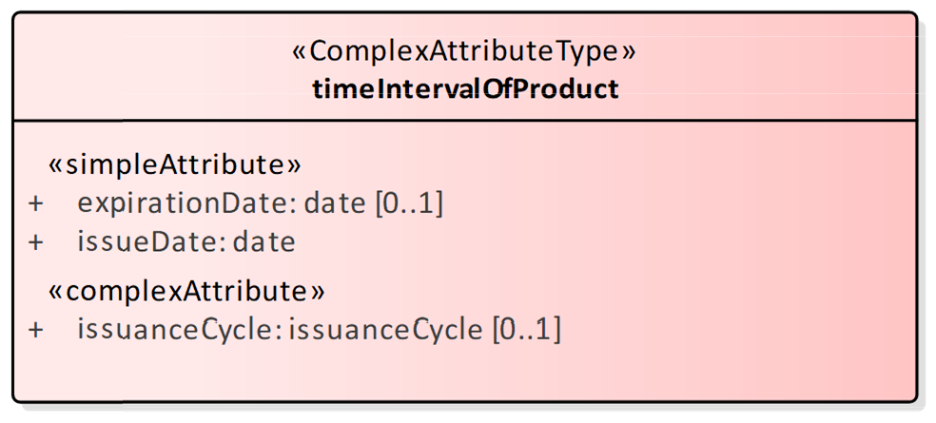

Figure 4-5 – timeIntervalOfProduct (complex attribute)

## Geometric representation

Geometric representation is the digital description of the spatial component of an object as described in S-100 and ISO 19107. This Product Specification uses type of geometry: GM_Surface.

CNPs are encoded as vector entities which conform to S-100 geometry configuration level 3a (S-100 Part 7). S-128 further constrains Level 3a with the following: The distance between two consecutive control points must not be less than 0.3 mm at a permitted display scale.

The following exception applies to S-128:

* Soundings features which use GM_Point or GM_Multipoint with three dimensional coordinates are not currently included in S-128.

# Coordinate Reference Systems (CRS)

## Introduction

The location of an object in the S-100 Standard is defined by means of coordinates which relate a feature to a position. The coordinate reference system used for this Product Specification is World Geodetic System 1984 (WGS 84) which is defined by the European Petroleum Survey Group (EPSG) code 4326, (or similar - North American Datum 1983 / Canadian Spatial Reference System).

Spatial data is expressed as latitude (φ) and longitude (λ) geographic coordinates. Latitude values are stored as a negative number to represent a position south of the Equator. Longitude values are stored as a negative number to represent a position west of the International Prime Meridian. Coordinates are expressed as real value, degree / degree decimal format. Datasets conforming to this product specification are not projected.

Horizontal coordinate reference system: WGS84

Projection:  None

Vertical coordinate reference system: Although all coordinates in a data set must refer to the same horizontal CRS different Vertical Datums can be used for the depth component of a coordinate tuple. Therefore the vertical CRS can be repeated. For each Vertical CRS a unique identifier is defined. Those identifiers will be used to indicate which Vertical CRS is used. Units must be in meters.

Temporal reference system: Gregorian calendar

Coordinate reference system registry: [EPSG Geodetic Parameter Registry](http://www.epsg-registry.org/)

Date type (according to ISO 19115): 002 - publication

Responsible party: International Organisation of Oil and Gas Producers (IOGP)

URL: <https://epsg.org/home.html>

## Horizontal reference system

Positional data is expressed in latitude and longitude geographic coordinates to one of the reference horizontal reference systems defined in the horizontalDatum attribute. Unless otherwise defined, the World Geodetic System 84 (WGS 84) will be used for CNP data products.

## Projection

CNP data products are un-projected.

## Vertical coordinate reference system

Although all coordinates in a data set must refer to the same horizontal CRS different Vertical Datums can be used for the depth component of a coordinate tuple. Therefore the vertical CRS can be repeated. For each Vertical CRS a unique identifier is defined. Those identifiers will be used to indicate which Vertical CRS is used. Units must be in meters.

## Temporal reference system

Time is measured by reference to Calendar dates and Clock time in accordance with ISO 19108:2002 Temporal Schema, clause 5.4.4.

## Coverage of nautical products data and scale

CNP data must be compiled in the best applicable scale. The use of the data itself is "scale independent". That means that the data can be used at any scale. S-100 allows the association of multiple spatial attributes to a single feature instance. Each of these spatial attributes can in principle be qualified by maximum and minimum scales.

For example, it is possible, within one dataset, to have a single instance of a feature that has more than one area geometry. Each of these geometries has different scale max/min attributes. Moreover, due to cluttering in smaller scales, the scale minimum attribute may be used to turn off portrayal of some features at smaller scales.

# Data Quality

## Introduction

Data quality allows users and user systems to assess fitness for use of the provided data. Data quality measures and the associated evaluation are reported as metadata of a data product. This metadata improves interoperability with other data products and provides usage by user groups that the data product was not originally intended for. The secondary users can make assessments of the data product usefulness in their application based on the reported data quality measures.

For S-128 the following data quality elements have been included:

* + Conformance to this Product Specification;
  + Intended purpose of the data product;
  + Completeness of the data product in terms of coverage;
  + Logical Consistency;
  + Positional uncertainty and accuracy;
  + Thematic accuracy;
  + Temporal quality;
  + Aggregation measures;
  + Elements specifically required for the data product (none currently identified for S-128);
  + Validation checks or conformance checks including:
    - General tests for dataset integrity;
    - Specific tests for a specific data model.

# Data Capture and Classification

S-128 products must be generated from data obtained from the product creator and released by an appropriate CNP defining authority such as Hydrographic Offices. The product creator can be described for each product within a CNP.

The production process used to generate CNP products may be described in the dataset metadata.

Table 7-1 – Data capture information

|  |  |  |  |
| --- | --- | --- | --- |
| **Item Name** | **Description** | **Multiplicity** | **Type** |
| dataSource | Identification of the kinds of data sources usable to product datasets compliant with the considering Specification | 0..* | CharacterString |
| productionProcess | Link to a textual description of the production process (including encoding guide) applicable to the datasets compliant with the considering Specification | 0..* | CharacterString (URL) |

# Maintenance

## Introduction

Datasets are maintained as needed and must include mechanisms for CNP updating. Data updates will be made by New Editions or updates. The maintenance and update frequency of CNP datasets should be defined by the producers (official national authority) implementing this Specification.

Data Producers must use applicable sources to maintain and update data and provide a brief description of the sources that were used to produce the dataset in the appropriate metadata field.

## Production process for base and update datasets

Data Producers should follow their established production processes for maintaining and updating datasets. Data is produced against the DCEG and checked against the appropriate set of validation checks in IHO Publication S-158:128.

## Dataset updates and cancellation

The purpose of issue of the dataset is indicated in the “purpose” field of the dataset discovery metadata. In order to terminate a dataset, an update dataset file is created for which the Edition number must be set to 0 (000). This convention is only used to cancel a base dataset file.

Where a dataset is cancelled and its name is reused at a later date, the issue date must be greater than the issue date of the cancelled dataset.

When the dataset is cancelled, it must be removed from the system.

An Exchange Set may contain base dataset files and update dataset files for the same datasets. Under these circumstances the update dataset files must follow in the correct sequential order from the last update applied to the base dataset file.

## Support file updates

The purpose of issue is indicated in the “purpose” field of the support file discovery metadata. Support files carrying the “deletion” flag in metadata must be removed from the system. When a feature or information type pointing to a text, picture, or application file is deleted or updated so that it no longer references the file, the system software must check to see whether any other feature or information type references the same file, before that file is deleted.

Updates, in form of a New Edition or a replacement, or deletions of a support file may require concurrent updates to feature or information type instance attributes that depend on the file; for example, fileReference, and fileLocator attributes.

## Feature and Portrayal Catalogues

For each new version of the S-128 Product Specification a new Feature and Portrayal Catalogue may be released. The system must be able to manage datasets and their Catalogues that are created on different versions of the S-128 Product Specification.

## Feature history, version, and change tracking

If applications or production systems require versioning of individual instances of feature or information types, maintenance of histories, or change tracking, the methods for versioning, history management, and change tracking and display are left to the application or production system.

## Dataset encryption

Dataset encryption should follow S-100 Edition 5.2, Part 15.

# Portrayal

S-128 portrayal is covered by the portrayal model as defined in S-100. The Portrayal Catalogue defines symbology and the portrayal rules for each feature/attribute combination contained in the Feature Catalogue.

S-128 uses the portrayal process defined in S-100 Part 9.

## Portrayal Catalogue

Citation information for the Portrayal Catalogue is provided in Table 9-1 below

Table 9-1 – S-128 Portrayal Catalogue

|  |  |  |  |
| --- | --- | --- | --- |
| **No.** | **ISO class or attribute** | **Type** | **Value** |
| -- | CI_Citation | Class | -- |
| 1 | title | CharacterString | S-128 Portrayal Catalogue |
| 2 | date | CI_Date (class) | -- |
| 2.1 | date | DateTime | 2024-02-16 (or later - see note) |
| 2.2 | dateType | CI_DateTypeCode (ISO codelist) | publication |
| 3 | edition | CharacterString | 1.0.0 |
| 4 | editionDate | DateTime | 2024-02-16 (or later - see note) |
| 5 | citedResponsibleParty | CI_Responsibility (class) | -- |
| 5.1 | role | CI_RoleCode  (ISO codelist) | publisher |
| 5.2 | party | CI_Organisation (class) | -- |
| 5.2.1 | name | CharacterString | International Hydrographic Organization |
| 6 | otherCitationDetails | CharacterString | (reserved) |
| 7 | onlineResource | CI_OnlineResource (class) | -- |
| 7.1 | linkage | CharacterString (URL) | https://registry.iho.int/ |
| 7.2 | name | CharacterString | S-128 Portrayal Catalogue |
| 7.3 | description | CharacterString | XML Portrayal Catalogue accompanied by related files for symbols, colour profiles, rules, etc |

# Data Product Format (Encoding)

## Introduction

The principal encoding will be the Open Geospatial Consortium (OGC), Geography Markup Language (GML) format. GML is an XML grammar designed to express geographical features. It serves as a modelling language for geographic systems as well as an open interchange format for geographic transactions.

Format Name: GML

Version: 3.2.1

Character Set: UTF-8

Specification: <https://www.ogc.org>

## Coordinate encoding in spatial primitives

Values of latitude and longitude must not be more accurate than 7 decimal places. Coordinates must be encoded as decimals in the format described in clause 10.2.1.

Geometry may be encoded either inline or by reference to a spatial primitives located elsewhere in the dataset that encodes the actual coordinate values. The GML conventions for references and axis order must be followed. The CRS shall be identified using the URI convention for SRS specified by OGC, which is http://www.opengis.net/def/crs/EPSG/0/4326 (S-100 Part 10b). The axis order is latitude/longitude.

### Encoding of coordinates as decimals

Values should be coded as decimal numbers with 7 or fewer digits after the decimal. The normative encoding is in degrees, with an accuracy of 10-7 degrees; that is, 7 digits after the decimal point.

The decimal point must be indicated by the “.” character.

Trailing zeroes after the decimal point (and the decimal point itself if appropriate) may be omitted at producer discretion, but the accuracy must still be as indicated (for example, 10-7 degrees for coordinates of default accuracy).

## Numeric attribute encoding

Floating point and integer attribute values must not contain leading zeros. Floating point attribute values must not contain non-significant trailing zeros.

## Text attribute values

Character strings must be encoded using the character set defined in ISO 10646-1, in Unicode Transformation Format-8 (UTF-8).

## Mandatory attribute values

There are four reasons why attribute values may be considered mandatory:

* They determine whether a feature is in the display base.
* Certain features make no logical sense without specific attributes.
* Some attributes are necessary to determine which symbol is to be displayed.
* Some attributes are required for safety of navigation.

All mandatory attributes are identified in the Feature Catalogue and summarized in Annex A – Data Classification and Encoding Guide.

## Data overlap

S-128 datasets can overlap other S-128 datasets.

## Data extent

Datasets must not cross the 180° meridian of longitude.

# Data Product Delivery

## Data product delivery information

This data Product Specification defines GML as the primary format in which CNP data products are delivered. The delivery format is described by the following items (from ISO 19131:2008) format name, version, specification, language, and character set.

* GML is an XML encoding for the transport and storage of geographic information, including both the geometry and the properties of geographic features, between distributed systems. The XML Schema for the GML Application Schema is provided in a Schema document S128.xsd which imports other Schema(s) defining common types. (All files are available on the S-100 distribution site <https://github.com/IHO-S100WG>). Feature instances shall validate against S128.xsd and conform to all other requirements specified in this data Product Specification including all constraints not captured in the XML Schema document.

### Dataset loading

Datasets must always be loaded in the order of base dataset first, then update datasets in the corrected sequential order. Systems are not to load updates out of order, for example if update 1-5 is present and update 6 is missing, update 7 must not be loaded.

### New Editions

When a New Edition of a dataset is received, the system must replace the previous Edition, along with any updates, with the New Edition of the dataset. Loading of subsequent updates follows the same rule as above.

### Update

When an update to a dataset is received by the system it must add new features or replace definitions but it’s not possible to delete features. For full details of the updating procedure please refer to S-100 Edition 5.2, Part 10b, clause 10b-11.5 Updating.

Data servers can create a single S-128 catalogue per S-100 product type, for example an S-128 for S-101 and an S-128 for S-102, or a mixed S-128 catalogue file with multiple products. When an S-128 is created for one product type, the S-128 should not alter the revision status of the other products in the ECDIS.

Not every S-100 Exchange Set will contain an S-128 file. If an S-128 file has not been received and updated within 4 weeks of the last S-128 file loaded, the ECDIS update status of all products must be set to ‘Not Up To Date’.

## Dataset

### Datasets

A dataset is a grouping of features, attributes, geometry, and metadata which comprises a specific coverage. The types of CNP datasets produces and contained within an Exchange Set are listed in Table 11-1 below:

Table 11-1 – CNP dataset types

|  |  |
| --- | --- |
| **Dataset** | **Explanations** |
| New dataset (base dataset) | No data has previously been produced for this areaor there is a significant change from the existing, for example, coverage or extent. |
| New Edition of a dataset (base dataset) | No data has previously been produced for this area. Each New Edition of a dataset must have the same name as the dataset that it replaces and should have the same spatial extents. The Edition number in the dataset discovery metadata shall increment up by one from the previous Edition. |
| Update dataset | A delta change of the latest Edition of a dataset. If there is more than one update dataset, the subsequent update will be a delta of the base dataset  + earlier update datasets. |
| Re-issue (base dataset) | Including all the updates applied to the original dataset up to the date of the reissue. A Re-issue does not contain any new information additional to that previously issued by updates. |
| Cancellation | Indicates the dataset or Catalogue should no longer be used and can be deleted.  For a cancellation, set:  • fileName = fileName of the cancelled dataset  • purpose = cancellation  • issueDate and issueTime = the issue date and time of the cancellation  • replacedData = true if and only if the cancelled dataset is replaced by another dataset; otherwise false. This attribute must be populated for a cancellation.  • dataReplacement = fileName of the replacement dataset (if and only if the cancelled dataset is replaced by another dataset). This attribute must be populated when replacedData = true.  • all other mandatory attributes to the same values as in the discovery metadata block for the dataset being cancelled. |

Where the limit of a Data Coverage feature for a base CNP dataset is to be changed, this must be done by issuing a New Edition of the dataset.

#### Content of update datasets

Update datasets can only contain replacements, deletions, and additions of whole feature instances or information instances. This means that when a feature or information instance is updated, the new version must contain all the attributes of the old instance, including any inline spatial attributes (that is, inline geometry), except those attributes that are being removed.

An association to an instance of a feature or information type is treated as an attribute of the referring instance, and therefore adding or deleting an association means the original referring instance must be replaced with a new version. The instance at the other end of the association needs to be replaced if and only if it contains a reference to the first instance.

Spatial objects that are not inline (that is, geometry that is encoded as an independent spatial object in the dataset) are treated like any other object; that is, it needs to be updated if and only if the primitive has changed (for example, a coordinate is updated).

Feature and information type instances are deleted without replacement by setting the fixedDateRange.dateEnd attribute of the instance to the date of deletion, which will usually be the issue date of the update.

#### Dataset size

CNP datasets should not exceed 100MB.

### Dataset file naming

All dataset files will have unique world-wide file identifiers. The file identifier of the dataset should not be used to describe the physical content of the file. The dataset file metadata that accompanies the file will inform the user of the name and purpose of the file (new, replacement or deletion).

In this encoding the dataset files are named according to the specifications given below:

128CCCCXXXXXXXXXXXXXX.GML

The main part forms an identifier where:

* The first three characters are always “128” and identify the dataset as an S-128 dataset.
* The next four characters identify the issuing agency by its alphanumeric agency code in the S-100 tab of the IHO Producer Code Register in the IHO GI Registry (that is, the IHO is identified as “00AA”, not “1810”).
* The eighth up to the twenty-first characters can be used in any way by the producer to provide a unique file name for the dataset. The following characters are allowed in the dataset name: A to Z, 0 to 9 and the special character _ (underscore). The ninth through twenty-first characters are optional (that is, at least one character must be used).

### Update dataset file naming

All Update dataset files will have an identical name to the base dataset, aside from the separator and update number sequence.

In this encoding the Update dataset files are named according to the specifications given below:

128CCCCXXXXXXXXXXXXXX_XXX.GML

The main part forms an identifier where:

* The first up to the twenty-first characters are the same as the dataset being updated and therefore conform to the rules described in clause 11.2.2.
* The next character must be an underscore “_”.
* The next three characters must be numerical (000-999) to indicate the place of the update dataset in the update sequence.

## Support files

Support files contain ancillary textual or graphic information in separate (linked to the dataset) files. The following formats are allowed for support files:

* Plain text files must contain only general text as defined in this Standard. Files must use the UTF- 8 character set encoding.
* HTML and XML files must contain only text and markup as defined in the relevant W3C standards. Files must use the UTF-8 character set encoding. References in datasets to HTML and XML support files must treat them as text files (that is, they should not be referenced using attributes intended for picture files).
* Picture files must be in the Tagged Image File Format (TIFF) [Edition 6.0].

Support files shall be used for data management and additional information to users. Portraying and using support files in ECDIS or other systems is not mandatory. Table 11-2 describes the constraints on support file formats and provides the corresponding file extensions.

Table 11-2 – Support file formats and extensions

|  |  |  |
| --- | --- | --- |
| **File type** | **Extension** | **Description** |
| Text | TXT | Plain-text files |
| HTM | HTML files must only include inline or embedded Cascading Style Sheet (CSS) information and must not contain embedded Javascript or other dynamic content; for example DHTML, Flash etc |
| XML | XML documents must only be included in accordance with guidance provided within the Data Classification and Encoding Guide (Annex A) and must not contain embedded Javascript or other dynamic content |
| Picture | TIF | Baseline TIFF 6.0 |

### Support file naming

All support files will have unique world-wide file identifiers. The file identifier of support information should not be used to describe the physical content of the file. The support file metadata that accompanies the file will inform the user of the name and purpose of the file (new, replacement or deletion).

In this encoding the support files are named according to the specifications given below:

128CCCCXXXXXXXXXXXXXX.YYY

The main part forms an identifier where:

* The first three characters are always “128” and identify the dataset as an S-128 dataset.
* The next four characters identify the issuing agency by its alphanumeric agency code in the S-100 tab of the IHO Producer Code Register in the IHO GI Registry (that is, the IHO is identified as “00AA”, not “1810”).
* The eighth up to the twenty-first characters can be used in any way by the producer to provide a unique file name for the dataset. The following characters are allowed in the dataset name: A to Z, 0 to 9, and the special character _ (underscore). The ninth through twenty-first characters are optional (that is, at least one character must be used).
* .YYY – support file extension. The YYY portion must conform to the file format as described in Table 11-3 above.

## Exchange Set

Data which conforms to this product specification must be delivered by means of an Exchange Set.

An Exchange Set will consist of one or more CNP datasets. An Exchange Set may also include one or more support files containing supplementary information encoded in separate files. These are linked to the CNP dataset features, by feature and information type attributes defined in the Application Schema; for example, **fileReference**. Each Exchange Set will include a single (XML) Catalogue file. S-128 Exchange Set Catalogues conform to S-100 Edition 5.2.0, Part 17, Figure 17-6 without modification, containing discovery metadata for each CNP dataset as well as support files. S-128 Exchange Set structure conforms to S-100 Edition 5.2.0, Part 17, Figure 17-2 without modification.

# Metadata

## Introduction

The CNP metadata specification conforms to the S-100 metadata specification in Part 4a, which is a profile of the ISO 19115-1 Standard. These documents provide a structure for describing digital geographic data and define metadata elements, a common set of metadata terminology, definitions, and extension procedures.

## Discovery metadata

The overall structure of metadata in S-128 Exchange Sets is the same as in S-100, and is depicted in Figure 12-1 below. Metadata in Exchange Sets consists of discovery metadata for the datasets and support files in the Exchange Set (classes S100_DatasetDiscoveryMetadata and S100_SupportFileDiscoveryMetadata); metadata in ISO 19115-1 format for datasets; and metadata about any Feature, Portrayal, or Interoperability Catalogues which are in the Exchange Set (S100_CatalogueMetadata).

The discovery metadata classes have numerous attributes which enable important information about the datasets and accompanying support files to be examined without the need to process the data, for example decrypt, decompress, load, etc. Other Catalogues such as Feature and Portrayal Catalogues can be included in the Exchange Set in support of the datasets.

More detailed information for the classes is depicted in Figure 12-2 and details about the metadata classes are provided in clauses 12.2 - 12.5.

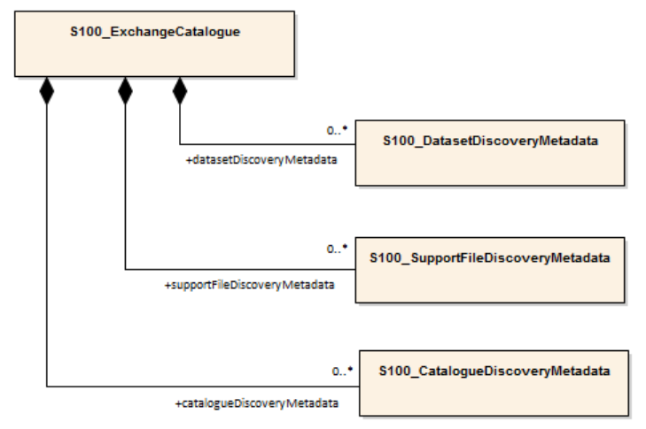

Figure 12‑1 Relationship between Exchange Catalogue, discovery metadata, and dataset (from S-100 Edition 5.2.0, Figure 17-6)

The detailed structure of the S-128 Exchange Catalogue is depicted in Figure 12-2. This figure is derived from S-100 Edition 5.2.0, Part 17, Figure 17-7 with the following restriction:

* Elements that are optional in the generic S-100 Catalogue model but not used in S-128 are not shown; for example, the ISO 8211 and HDF5 formats in S100_EncodingFormat.

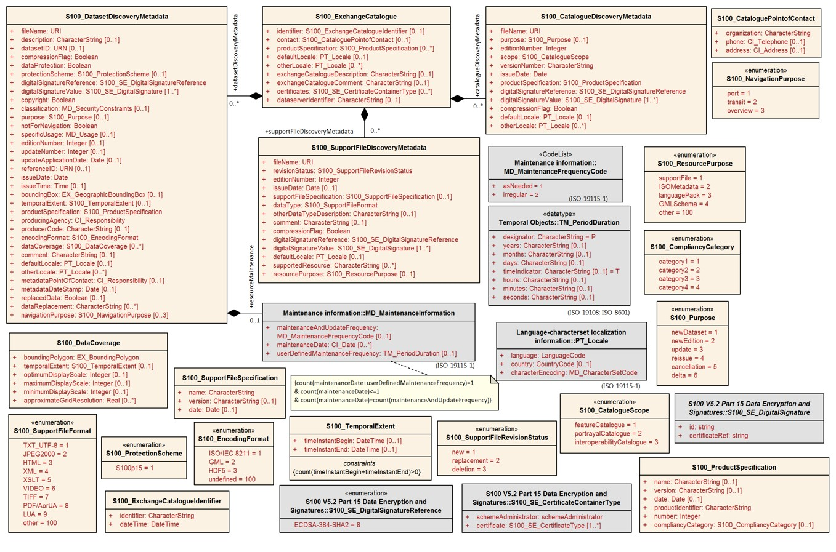Figure 12-2 – Details of Exchange Set Catalogue classes. (Derived from S-100 Edition 5.2.0, Figure 17-7)

The following clauses define the mandatory and optional metadata needed for S-128. In some cases the metadata may be repeated in a national language. If this is the case it is noted in the Remarks column.

In the following clauses, wherever S-128 makes an optional S-100 metadata attribute mandatory (that is, restricts multiplicity from 0.. to 1..), the restricted multiplicity is shown in place of the multiplicity given in S-100 Part 17. When this is done, the Remarks column contains a note about the restriction. Further, enumerations in the Figure and the following clauses show only the values allowed in S-128 Exchange Catalogues.

For Product Specifications to be used in S-100 ECDIS, covered by S-98, a third principle is that the S-100 Exchange Catalogue profile cannot be extended at the Product Specification level. This principle exists so that implementers of the S-100 Exchange Catalogue profile are not required to consider product specific extensions.

### S100_ExchangeCatalogue

Each exchange set has a single S100_ExchangeCatalogue which contains meta information for the data and support files in the Exchange Set.

|  |  |  |  |  |
| --- | --- | --- | --- | --- |
| **Name** | **Description** | **Mult** | **Type** | **Remarks** |
| S100_ExchangeCatalogue | An exchange catalogue contains the discovery metadata about the exchange datasets and support files | - | - |  |
| identifier | Uniquely identifies this Exchange Catalogue | 0..1 | S100_ExchangeCatalogueIdentifier |  |
| contact | Details about the issuer of this Exchange Catalogue | 0..1 | S100_CataloguePointOfContact |  |
| productSpecification | Details about the Product Specifications used for the datasets contained in the Exchange Catalogue | 0..* | S100_ProductSpecification |  |
| defaultLocale | Default language and character set used for all metadata records in this Exchange Catalogue | 0..1 | PT_Locale | Default is English and UTF-8 |
| otherLocale | Other languages and character sets used for the localized metadata records in this Exchange Catalogue | 0..* | PT_Locale | Required if any localized entries are present in the Exchange Catalogue |
| exchangeCatalogueDescription | Description of what the Exchange Catalogue contains | 0..1 | CharacterString |  |
| exchangeCatalogueComment | Any additional Information | 0..1 | CharacterString |  |
| certificates | Signed public key certificates referred to by digital signatures in the Exchange Set | 0..* | S100_SE_CertificateContainerType | Content defined in S-100 Part 15. All certificates used, except the SA root certificate (installed separately by the implementing system) shall be included |
| dataServerIdentifier | Identifies the data server for the permit | 0..1 | CharacterString |  |
| datasetDiscoveryMetadata | Exchange Catalogues may include or reference discovery metadata for the datasets in the Exchange Set | 0..* | Aggregation  S100_DatasetDiscoveryMetadata |  |
| catalogueDiscoveryMetadata | Metadata for Catalogue | 0..* | Aggregation  S100_CatalogueDiscoveryMetadata | Metadata for the feature, portrayal, and interoperability catalogues, if any |
| supportFileDiscoveryMetadata | Exchange Catalogues may include or reference discovery metadata for the support files in the Exchange Set | 0..* | Aggregation  S100_SupportFileDiscoveryMetadata |  |

#### S100_ExchangeCatalogueIdentifier

|  |  |  |  |  |  |
| --- | --- | --- | --- | --- | --- |
| **Role Name** | **Name** | **Description** | **Mult** | **Type** | **Remarks** |
| Class | S100_ExchangeCatalogueIdentifier | An identifier for an Exchange Catalogue | - | - | The concatenation of identifier, editionNumber and dateTime form the unique name |
| Attribute | identifier | Uniquely identifies this Exchange Catalogue | 1 | CharacterString | <S100XC:identifier>US_101_20200101_120101_01</S100XC:identifier> |
| Attribute | dateTime | Creation date and time of the Exchange Catalogue, including time zone | 1 | DateTime | Format: yyyy-mm-ddThh:mm:ssZ |

#### S100_CataloguePointofContact

|  |  |  |  |  |  |
| --- | --- | --- | --- | --- | --- |
| **Role Name** | **Name** | **Description** | **Mult** | **Type** | **Remarks** |
| Class | S100_CataloguePointOfContact | Contact details of the issuer of this Exchange Catalogue | - | - | - |
| Attribute | organization | The organization distributing this Exchange Catalogue | 1 | CharacterString | This could be an individual producer, value added reseller, etc |
| Attribute | phone | The phone number of the organization | 0..1 | CI_Telephone |  |
| Attribute | address | The address of the organization | 0..1 | CI_Address |  |

### S100_DatasetDiscoveryMetadata

|  |  |  |  |  |
| --- | --- | --- | --- | --- |
| **Name** | **Description** | **Mult** | **Type** | **Remarks** |
| S100_DatasetDiscoveryMetadata | Metadata about the individual datasets in the Exchange Catalogue | - | - | - |
| fileName | Dataset file name | 1 | URI | See Part 1, clause 1-4.6 |
| description | Short description giving the area or location covered by the dataset | 0..1 | CharacterString | For example: A harbour or port name, between two named locations etc |
| datasetID | Dataset ID expressed as a Maritime Resource Name | 0..1 | URN | The URN must be an MRN |
| compressionFlag | Indicates if the resource is compressed | 1 | Boolean | ***True*** indicates a compressed dataset resource  ***False*** indicates an uncompressed dataset resource |
| dataProtection | Indicates if the data is encrypted | 1 | Boolean | ***True*** indicates an encrypted dataset resource  ***False*** indicates an unencrypted dataset resource |
| protectionScheme | Specification or method used for data protection | 0..1 | S100_ProtectionScheme |  |
| digitalSignatureReference | Specifies the algorithm used to compute digitalSignatureValue | 1 | S100_SE_DigitalSignatureReference (see S-100 Part 15) |  |
| digitalSignatureValue | Value derived from the digital signature | 1..* | S100_SE_DigitalSignature (see S-100 Part 15) | The value resulting from application of digitalSignatureReference  Implemented as the digital signature format specified in S-100 Part 15 |
| copyright | Indicates if the dataset is copyrighted | 1 | Boolean | ***True*** indicates the resource is copyrighted  ***False*** Indicates the resource is not copyrighted |
| classification | Indicates the security classification of the dataset | 0..1 | Class  MD_SecurityConstraints>MD_ClassificationCode (codelist) | 1. unclassified  2. restricted  3. confidential  4. secret  5. top secret  6. sensitive but unclassified  7. for official use only  8. protected  9. limited distribution |
| purpose | The purpose for which the dataset has been issued | 0..1 | S100_Purpose |  |
| notForNavigation | Indicates the dataset is not intended to be used for navigation | 1 | Boolean | ***True*** indicates the dataset is not intended to be used for navigation  ***False*** indicates the dataset is intended to be used for navigation |
| specificUsage | The use for which the dataset is intended | 0..1 | MD_USAGE>specificUsage (character string) |  |
| editionNumber | The edition number of the dataset | 0..1 | Integer | When a data set is initially created, the edition number 1 is assigned to it. The edition number is increased by 1 at each new edition. Edition number remains the same for a re-issue |
| updateNumber | Update number assigned to the dataset and increased by one for each subsequent update | 0..1 | Integer | Update number 0 is assigned to a new dataset |
| updateApplicationDate | This date is only used for the base cell files (that is new data sets, re-issue and new edition), not update cell files. All updates dated on or before this date must have been applied by the producer | 0..1 | Date |  |
| referenceID | Reference back to the datasetID | 0..1 | URN | Update metadata refers to the datasetID of the dataset metadata. This is used if and only if the dataset is an update The URN must be an MRN |
| issueDate | Date on which the data was made available by the data producer | 1 | Date |  |
| issueTime | Time of day at which the data was made available by the data producer | 0..1 | Time | The S-100 datatype Time |
| boundingBox | The extent of the dataset limits | 0..1 | EX_GeographicBoundingBox |  |
| temporalExtent | Specification of the temporal extent of the dataset | 0..1 | S100_TemporalExtent | The temporal extent is encoded as the date/time of the earliest and latest data records (in coverage datasets) or date/time ranges (in vector datasets)  If there is more than one feature in a dataset, the earliest and latest time values of records in all features are used, which means the earliest and latest values may be from different features  If date/time information for a feature is not encoded in the dataset, it is treated for the purposes of this attribute as extending indefinitely in the appropriate direction on the time axis, limited by the issue date/time or the cancellation or supersession of the dataset  This attribute is encoded if and only if at least one of the start and end of the temporal extent is known |
| productSpecification | The Product Specification used to create this dataset | 1 | S100_ProductSpecification |  |
| producingAgency | Agency responsible for producing the data | 1 | CI_Responsibility>CI_Organisation | See S-100 Part 17, Table 17-3 |
| producerCode | The official IHO Producer Code from the IHO GI Registry, Producer Code Register | 0..1 | CharacterString |  |
| encodingFormat | The encoding format of the dataset | 1 | S100_EncodingFormat |  |
| dataCoverage | Provides information about data coverages within the dataset | 0..* | S100_DataCoverage |  |
| comment | Any additional information | 0..1 | CharacterString |  |
| defaultLocale | Default language and character set used in the Exchange Catalogue | 0..* | PT_Locale | In absence of defaultLocale the  language is English, UTF-8 |
| otherLocale | Other languages and character sets used in the Exchange Catalogue | 0..* | PT_Locale |  |
| metadataPointOfContact | Point of contact for metadata | 0..1 | CI_Responsibility>CI_Individual or  CI_Responsibility>CI_Organisation | Only if metadataPointOfContact is different to producingAgency |
| metadataDateStamp | Date stamp for metadata | 0..1 | Date | May or may not be the issue date |
| replacedData | If a data file is cancelled is it replaced by another data file | 0..1 | Boolean |  |
| dataReplacement | Cell name | 0..* | CharacterString | A dataset may be replaced by 1 or more datasets |
| navigationPurpose | Classification of intended navigation purpose (for Catalogue indexing purposes) | 0..3 | S100_NavigationPurpose | If Product Specification is intended for creation of navigational products this attribute should be mandatory |
| resourceMaintenance | Information about the frequency of resource updates, and the scope of those updates | 0..1 | MD_MaintenanceInformation | S-100 restricts the multiplicity to 0..1 and adds specific restrictions on the ISO  19115 structure and content. See clause MD_MaintenanceInformation later in this Part  Format: PnYnMnDTnHnMnS (XML built in type for ISO 8601 duration). See clause 17-4.9 |

#### S100_NavigationPurpose

|  |  |  |  |  |
| --- | --- | --- | --- | --- |
| **Item** | **Name** | **Description** | **Code** | **Remarks** |
| Enumeration | S100_NavigationPurpose | The navigational purpose of the dataset | - | - |
| Value | port | For port and near shore operations | 1 | - |
| Value | transit | For coast and planning purposes | 2 | - |
| Value | overview | For ocean crossing and planning purposes | 3 | - |

#### S100_DataCoverage

|  |  |  |  |  |
| --- | --- | --- | --- | --- |
| **Name** | **Description** | **Mult** | **Type** | **Remarks** |
| S100_DataCoverage | A spatial extent where data is provided; and the display scale information for the provided data | - | - | This field is used by user systems as part of the data loading and unloading algorithms and it is strongly encouraged that Product Specifications mandate the use of one or more of the displayScale provided as part of S100_DataCoverage |
| boundingPolygon | A polygon which defines the actual data limit | 1 | EX_BoundingPolygon | (See Note 1) |
| temporalExtent | Specification of the temporal extent of the coverage | 0..1 | S100_TemporalExtent | The remarks for temporalExtent in the dataset discovery block (S100_DatasetDiscoveryMetadata) apply, except that their scope is the individual coverage and not the dataset as a whole |
| optimumDisplayScale | The scale with which the data is optimally displayed | 0..1 | Integer | Example: A scale of 1:25000 is encoded as 25000 |
| maximumDisplayScale | The maximum scale with which the data is displayed | 0..1 | Integer | Example: 22000 for a maximum display scale of 1:22000 |
| minimumDisplayScale | The minimum scale with which the data is displayed | 0..1 | Integer |  |
| approximateGridResolution | The resolution of gridded or georeferenced data (in metres) | 0..1 | Real | A single value may be provided when all axes have a common resolution For multiple value provision, use axis order as specified in dataset May be approximate for ungeorectified data  For example, for 5 metre resolution. The value 5 must be encoded  (See Note 2) |

NOTE 1: boundingPolygon is restricted to a single GML Polygon with one exterior and 0 or more interiors expressed as Linear Rings using SRS EPSG:4326. The exterior and optional interiors shall be composed of a closed sequence of >=4 coordinate positions expressed individually or as a list (posList). The GML polygon shall have a valid GML identifier.

NOTE 2: approximateGridResolution: If the grid cell size varies over the extent of the grid, an approximated value based on model parameters or production metadata should be used.

#### S100_Purpose

|  |  |  |  |  |
| --- | --- | --- | --- | --- |
| **Item** | **Name** | **Description** | **Code** | **Remarks** |
| Enumeration | S100_Purpose | The purpose of the dataset | - |  |
| Value | newDataset | Brand new dataset | 1 | No data has previously been produced for this area |
| Value | newEdition | New edition of the dataset or Catalogue | 2 | Includes new information which has not been previously distributed by updates |
| Value | update | Dataset update | 3 | Changing some information in an existing dataset |
| Value | reissue | Dataset that has been re-issued | 4 | Includes all the updates applied to the original dataset up to the date of the re-issue. A re-issue does not contain any new information additional to that previously issued by updates |
| Value | cancellation | Dataset or catalogue that has been cancelled | 5 | Indicates the dataset or catalogue should no longer be used and can be deleted |
| Value | delta | Dataset difference | 6 | Reserved for future use |

#### S100_TemporalExtent

|  |  |  |  |  |  |
| --- | --- | --- | --- | --- | --- |
| **Role Name** | **Name** | **Description** | **Mult** | **Type** | **Remarks** |
| Class | S100_TemporalExtent | Temporal extent | - |  | At least one of the timeInstantBegin and timeInstantEnd attributes must be populated; if both are known, both must be populated. The absence of either begin or end indicates indefinite validity in the corresponding direction, limited by the issue date/time or the cancellation or supersession of the dataset |
| Attribute | timeInstantBegin | The instant at which the temporal extent begins | 0..1 | Date Time |  |
| Attribute | timeInstantEnd | The instant at which the temporal extent ends | 0..1 | Date Time |  |

#### S100_EncodingFormat

|  |  |  |  |  |
| --- | --- | --- | --- | --- |
| **Item** | **Name** | **Description** | **Code** | **Remarks** |
| Enumeration | S100_DataFormat | The encoding format | - | - |
| Value | ISO/IEC 8211 | The ISO/IEC 8211 data format as defined in Part 10a | 1 | - |
| Value | GML | The GML data format as defined in Part 10b | 2 | - |
| Value | HDF5 | The HDF5 data format as defined in Part 10c | 3 | - |
| Value | undefined | The encoding is defined in the Product Specification | 100 | Use Product Specification specific encoding means the data product and Product Specification is not intended for an IHO S-100 compliant system |

#### S100_ProductSpecification

|  |  |  |  |  |  |
| --- | --- | --- | --- | --- | --- |
| **Role Name** | **Name** | **Description** | **Mult** | **Type** | **Remarks** |
| Class | S100_ProductSpecification | The Product Specification contains the information needed to build the specified product | - | - | - |
| Attribute | name | The name of the Product Specification used to create the datasets | 0..1 | CharacterString | The name in the GI Registry should be used for this field. |
| Attribute | version | The version number of the Product Specification | 0..1 | CharacterString | TR 2/2007 specifies versioning of Product Specifications |
| Attribute | date | The version date of the Product Specification | 0..1 | Date |  |
| Attribute | productIdentifier | Machine readable unique identifier of a product type | 1 | CharacterString  (Restricted to Product ID values from the IHO Product Specification Register, in the IHO Geospatial Information (GI) Registry) | For example, “S-101” |
| Attribute | number | The number used to lookup the product in the Product Specification Register of the IHO GI Registry | 1 | Integer | For IHO Product Specifications these should be taken from the IHO Product Specification Register in the IHO Geospatial Information (GI) Registry |
| Attribute | compliancyCategory | The level of compliance of the Product Specification to S-100 | 0..1 | S100_CompliancyCategory | See S-100 Part 4a, clause 4a-5.5 |

#### S100_CompliancyCategory

|  |  |  |  |  |
| --- | --- | --- | --- | --- |
| **Item** | **Name** | **Description** | **Code** | **Remarks** |
| Enumeration | S100_CompliancyCategory |  | - | - |
| Value | category1 | IHO S-100 object model compliant | 1 |  |
| Value | category2 | IHO S-100 compliant with non-standard encoding | 2 |  |
| Value | category3 | IHO S-100 compliant with standard encoding | 3 |  |
| Value | category4 | IHO S-100 and IMO harmonized display compliant | 4 |  |

#### S100_ProtectionScheme

|  |  |  |  |  |
| --- | --- | --- | --- | --- |
| **Item** | **Name** | **Description** | **Code** | **Remarks** |
| Enumeration | S100_ProtectionScheme | Data protection schemes | - | - |
| Value | S100p15 | IHO S-100 Part 15 | 1 | See S-100 Part 15 |

### S100_SupportFileDiscoveryMetadata

|  |  |  |  |  |
| --- | --- | --- | --- | --- |
| **Name** | **Description** | **Mult** | **Type** | **Remarks** |
| S100_SupportFileDiscoveryMetadata | Metadata about the individual support files in the exchange catalogue | - | - | - |
| fileName | Name of the support file | 1 | URI | See S-100 Part 1, clause 1-4.6 |
| revisionStatus | The purpose for which the support file has been issued | 1 | S100_SuppoirtFileRevisionStatus | For example new, replacement, etc |
| editionNumber | The Edition number of the support file | 1 | Integer | When a data set is initially created, the Edition number 1 is assigned to it. The Edition number is increased by 1 at each new Edition. Edition number remains the same for a re-issue |
| issueDate | Date on which the data was made available by the Data Producer | 0..1 | Date |  |
| supportFileSpecification | The specification used to create this file | 0..1 | S100_SupportFileSpecification |  |
| dataType | The format of the support file | 1 | S100_SupportFileFormat |  |
| otherDataTypeDescription | Support file format other than those listed | 0..1 | CharacterString |  |
| comment | Optional comment | 0..1 | CharacterString |  |
| compressionFlag | Indicates if the resource is compressed | 1 | Boolean | *True* indicates a compressed resource  *False* indicates an uncompressed resource |
| digitalSignatureReference | Specifies the algorithm used to compute digitalSignatureValue | 1 | S100_SE_DigitalSignatureReference (see S-100 Part 15) | Reference to the appropriate digital signature algorithm |
| digitalSignatureValue | Value derived from the digital signature | 1..* | S100_DigitalSignature (see S-100 Part 15) | The value resulting from application of digitalSignatureReference  Implemented as the digital signature format specified in S-100 Part 15 |
| defaultLocale | Default language and character set used in the support file | 0..1 | PT_Locale | In absence of defaultLocale the language is English in UTF-8 A support file is expected to use only one as locale, Additional support files can be created for other locales |
| supportedResource | Identifier of the resource supported by this support file | 0..* | CharacterString | Conventions for identifiers are detailed in S-100 Part 15. S-100 allows file URI, digital signature or cryptographic hash checksums to be used |
| resourcePurpose | The purpose of the supporting resource | 0..1 | S100_ResourcePurpose | Identifies how the supporting resource is used |

#### S100_SupportFileFormat

|  |  |  |  |  |
| --- | --- | --- | --- | --- |
| **Item** | **Name** | **Description** | **Code** | **Remarks** |
| Enumeration | S100_SupportFileFormat | The format used for the support file | - | - |
| Value | ASCII | UTF-8 text excluding control codes | 1 |  |
| Value | JPEG2000 | JPEG2000 format | 2 | ISO 15444 |
| Value | HTML | Hypertext Markup Language | 3 |  |
| Value | XML | Extensible Markup Language | 4 |  |
| Value | XSLT | Extensible Stylesheet Language Transformations | 5 |  |
| Value | VIDEO | Representation of moving images in unspecified format | 6 |  |
| Value | TIFF | Tagged Image File Format | 7 |  |
| Value | PDF/AorUA | Portable Document Format | 8 | ISO 19005, ISO 32000  Product Specification developers should take careful consideration in using PDF as a support file format. It is recommended that PDF never be used in products that will be used on a navigation system as it may impair night vision  Must be PDF/A or UA |
| Value | LUA | Lua programming language | 9 |  |
| Value | other | Other format | 100 |  |

#### S100_SupportFileRevisionStatus

|  |  |  |  |  |
| --- | --- | --- | --- | --- |
| **Item** | **Name** | **Description** | **Code** | **Remarks** |
| Enumeration | S100_ SupportFileRevisionStatus | The reason for inclusion of the support file in this Exchange Set | - | - |
| Value | new | A file which is new | 1 | Signifies a new file |
| Value | replacement | A file which replaces an existing file | 2 | Signifies a replacement for a file of the same name |
| Value | deletion | Deletes an existing file | 3 | Signifies deletion of a file of that name |

#### S100_ResourcePurpose

|  |  |  |  |  |
| --- | --- | --- | --- | --- |
| **Item** | **Name** | **Description** | **Code** | **Remarks** |
| Enumeration | S100_ResourcePurpose | Defines the purpose of the supporting resource | - | - |
| Value | supportFile | A support file | 1 |  |
| Value | ISOMetadata | Dataset metadata in ISO format | 2 |  |
| Value | languagePack | A Language pack | 3 |  |
| Value | GMLSchema | GML Application Schema | 4 |  |
| Value | other | A type of resource not otherwise described | 100 |  |

#### S100_SupportFileSpecification

|  |  |  |  |  |  |
| --- | --- | --- | --- | --- | --- |
| **Role Name** | **Name** | **Description** | **Mult** | **Type** | **Remarks** |
| Class | S100_SupportFileSpecification | The standard or specification to which a support file conforms | - | - | - |
| Attribute | name | The name of the specification used to create the support file | 1 | CharacterString |  |
| Attribute | version | The version number of the specification | 0..1 | CharacterString |  |
| Attribute | date | The version date of the specification | 0..1 | Date |  |

### S100_CatalogueDiscoveryMetadata

|  |  |  |  |  |
| --- | --- | --- | --- | --- |
| **Name** | **Description** | **Mult** | **Type** | **Remarks** |
| S100_CatalogueMetadata | Class for S-100 Catalogue metadata | - | - | - |
| filename | The name for the Catalogue | 1 | URI |  |
| purpose | The purpose for which the Catalogue has been issued | 0..1 | S100_Purpose  (codelist) | The values must be on of the following: 2 new edition 5 cancellation  Default is new edition |
| editionNumber | The Edition number of the Catalogue | 1 | Integer | Initially set to 1 for a given productSpecification.number  Increased by 1 for each subsequent new Edition  Uniquely identifies the version of the Catalogue |
| scope | Subject domain of the Catalogue | 1 | S100_CatalogueScope |  |
| versionNumber | The version identifier of the Catalogue | 1 | CharacterString | Human readable version identifier |
| issueDate | The issue date of the Catalogue | 1 | Date |  |
| productSpecification | The Product Specification used to create this file | 1 | S100_ProductSpecification |  |
| digitalSignatureReference | Specifies the algorithm used to compute digitalSignatureValue | 1 | S100_SE_DigitalSignatureReference (see S-100 Part 15) | Reference to the appropriate digital signature algorithm |
| digitalSignatureValue | Value derived from the digital signature | 1..* | S100_SE_DigitalSignature (see S-100 Part 15) | The value resulting from application of digitalSignatureReference  Implemented as the digital signature format specified in S-100 Part 15 |
| compressionFlag | Indicates if the resource is compressed | 1 | Boolean | *True* indicates a compressed resource  *False* indicates an uncompressed resource |
| defaultLocale | Default language and character set used in the Catalogue | 0..1 | PT_Locale | In absence of defaultLocale the language is English in UTF-8 |
| otherLocale | Other languages and character sets used in the catalogue | 0..* | PT_Locale |  |

#### S100_CatalogueScope

|  |  |  |  |  |
| --- | --- | --- | --- | --- |
| **Item** | **Name** | **Description** | **Code** | **Remarks** |
| Enumeration | S100_CatalogueScope | The scope of the Catalogue | - | - |
| Value | featureCatalogue | S-100 Feature Catalogue | 1 |  |
| Value | portrayalCatalogue | S-100 Portrayal Catalogue | 2 |  |
| Value | interoperabilityCatalogue | S-100 Interoperability Catalogue | 3 |  |

### Miscellaneous metadata types

#### MD_MaintenanceInformation

|  |  |  |  |  |  |
| --- | --- | --- | --- | --- | --- |
| **Role Name** | **Name** | **Description** | **Mult** | **Type** | **Remarks** |
| Class | MD_MaintenanceInformation | Information about the scope and frequency of updating | - | - | S-100 restricts the ISO 19115-class to:   * prohibit maintenanceScope, maintenanceNote, and contact attributes; * define restrictions on maintenanceAndUpdate‌Frequency, maintenanceDate, and userDefinedMaintenance‌Frequency attributes |
| Attribute | maintenanceAndUpdateFrequency | Frequency with which changes and additions are made to the resource after the initial resource is completed | 0..1 | MD_MaintenanceFrequencyCode (codelist) | Must be populated if userDefinedMaintenanceFrequency is not present, otherwise optional.  See Table MD_Maintenance FrequencyCode in this Part for values allowed in S-100 metadata |
| Attribute | maintenanceDate | Date information associated with maintenance of the resource | 0..1 | CI_Date | Exactly one of maintenanceDate and userDefinedMaintenanceFrequency must be populated Allowed value for dateType: nextUpdate |
| Attribute | userDefinedMaintenanceFrequency | Maintenance period other than those defined | 0..1 | TM_PeriodDuration | Exactly one of maintenanceDate and userDefinedMaintenanceFrequency must be populated Only positive durations allowed |

#### MD_MaintenanceFrequencyCode

S-100 uses a subset of the values allowed in ISO 19115-1.

|  |  |  |  |  |
| --- | --- | --- | --- | --- |
| **Item** | **Name** | **Description** | **Code** | **Remarks** |
| Enumeration | MD_MaintenanceFrequencyCode | Frequency with which modifications and deletions are made to the data after it is first produced | - | S-100 is restricted to only the following values from the ISO 19115-1 codelist. The conditions for the use of a particular value are described in its Remarks |
| Value | asNeeded | Resource is updated as deemed necessary | 1 | Use only for datasets which normally use a regular interval for update or supersession, but will have the next update issued at an interval different from the usual  Allowed if and only if userDefinedMaintenanceFrequency is not populated |
| Value | irregular | Resource is updated in intervals that are uneven in duration | 2 | Use only for datasets which do not use a regular schedule for update or supersession  Allowed if and only if userDefinedMaintenanceFrequency is not populated |

#### PT_Locale

|  |  |  |  |  |  |
| --- | --- | --- | --- | --- | --- |
| **Role Name** | **Name** | **Description** | **Mult** | **Type** | **Remarks** |
| Class | PT_Locale | Description of a locale | - | - | From ISO 19115-1 |
| Attribute | language | Designation of the locale language | 1 | LanguageCode | ISO 639-2 3-letter language codes. |
| Attribute | country | Designation of the specific country of the locale language | 0..1 | CountryCode | ISO 3166-2 2-letter country codes |
| Attribute | characterEncoding | Designation of the character set to be used to encode the textual value of the locale | 1 | MD_CharacterSetCode | UTF-8 is used in S-100 |